**Fitzgerald, Desmond (1911-1987)**

Coming from a well-known Irish political family, Desmond Fitzgerald worked for Patrick Abercrombie on MENDELSOHN and CHERMAYEFF’S 1936 De La Warr Pavilion. After his return to Ireland he led a team of young Irish architects to design the INTERNATIONAL STYLE Dublin Airport for the Office of Public Works from 1937 to 1940. Influenced by Dutch models, the airport was designed to follow the circulation patterns of passengers, with a curved plan funnelling them out onto the airfield (see Fig. 1). A good example of the glamorous associations of inter-war air travel, the concrete and steel terminal referenced ocean liners with curved ends and stepped balconies, and the airport was awarded the RIAI Gold Medal for 1938-40. After World War II, Fitzgerald taught architecture in UCD and designed several other public buildings, as well as large office buildings in a monumental style.

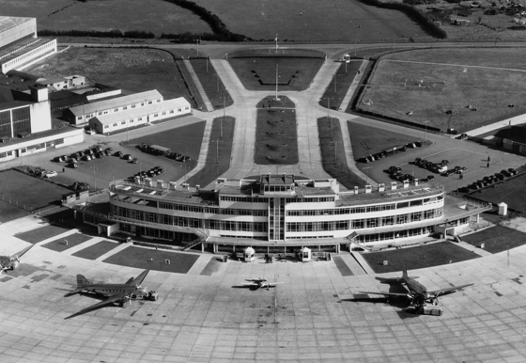

Figure 1 – Desmond Fitzgerald for the Office of Public Works, Dublin Airport, 1940 (IAA: Aer Lingus photo from Rothery, p. 221)

**List of Works**

1945 Shannon Airport terminal building, Rineanna, Co. Clare

1953 Moyne Institute, Trinity College Dublin.

1951 Cathleen’s Falls hydro-electric power station, near Ballyshannon, Co. Donegal.

1965 O’Connell Bridge House, D’Olier Street, Dublin.

c1970 D’Olier House, D’Olier, Street, Dublin.

**References and further reading**

Larmour, P. (2009) *Free State Architecture:  Modern Movement architecture in Ireland, 1922-1949*, Kinsale: Gandon Editions.

O’Dwyer, F. (2012) ‘Ahead of the Curve: Dublin Airport and the Duval Plan’, *Irish Arts Review*, Vol 29, No. 2, pp. 114-119 Available: <http://www.irishartsreview.com/html/features/Airport_29_2.html>

Oram, H. (1990) *Dublin Airport: The History*, Dublin: Aer Rianta.

Rothery, S. (1991) *Ireland and the New Architecture 1900-1940*, Dublin: Lilliput Press.

Rowley, E. “The Conditions of Twentieth Century Irish Architecture 1900-1970” in Kennedy, C. (ed.) (2011) *The Moderns: The Arts in Ireland from the 1900s to the 1970s*, Dublin: Irish Museum of Modern Art, pp. 418-475.

Irish Architectural Archive. Desmond Fitzgerald collection, Accs. 87/38

Web References

‘Fitzgerald, Desmond’, *Dictionary of Irish Architects*, Available: <http://www.dia.ie/architects/view/1900/FITZGERALD-DESMOND>

‘Fitzgerald, Desmond’, *Archiseek*, Available: <http://archiseek.com/2009/desmond-fitzgerald-1910-1987/>